Self Care Wheel Of Wellness

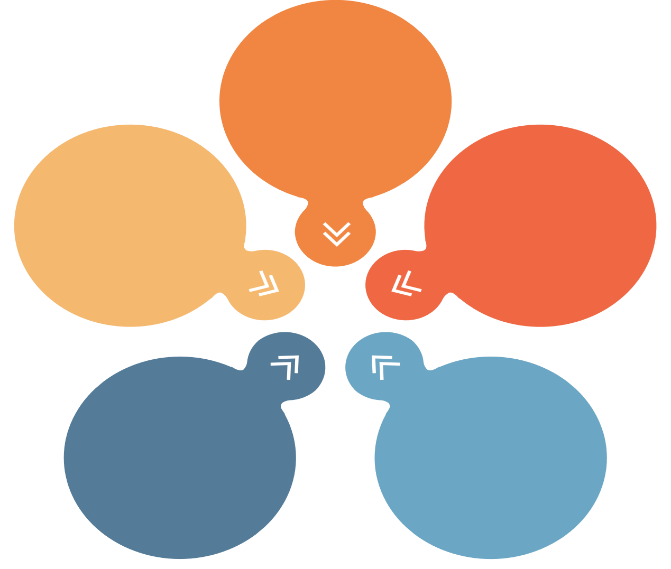

Consider your self-care needs & actions in various aspects of your life including

Physical

Psychological

Emotional

Spiritual

Relationships

